2005/03/14
To Schedule a Resource in Microsoft Outlook (such as a car or conference room)

- Open up Outlook
- Open up your Calendar
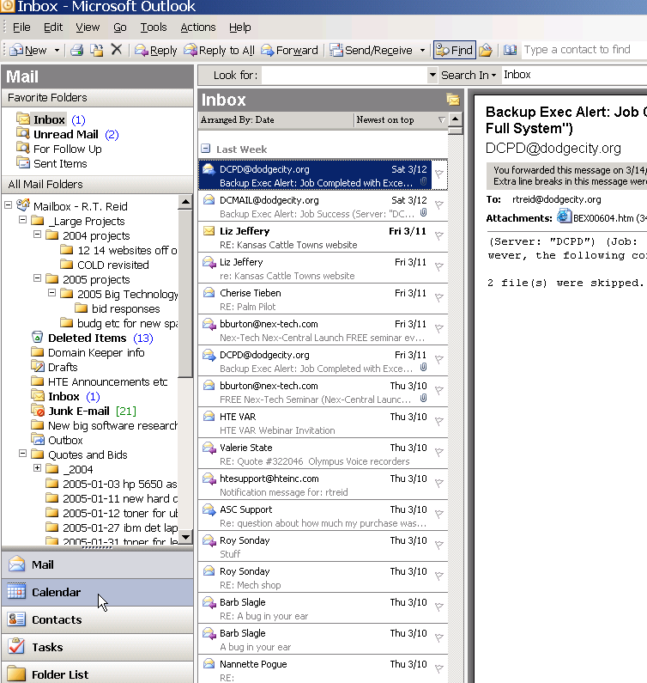

3) From the Calendar, select the day you want to use the resource in question on your own calendar (the default one). Then double click on the beginning of the time you want to use it.

